Flame Treatment Related Knowledge
Flame treatment :
At present, the light curing ink has not been directly used untreated PE、PP bottles.
Therefore, to print PE and PP bottles, the PP and PP must be polarized before printing, otherwise the UV ink cannot be firmly attached.

So how to deal with?
There are several methods of polarization treatment . In PE, PP plastic and bottles, most of them are treated by flame.

The result of this flame treatment is use of free radicals such as O、N0、OH and NH in the flame.
It can extract the surface oxygen of high polymers such as PE PP etc., and then perform surface oxidation according to the free radical mechanism, in addition, some polar oxygen-containing groups are introduced to undergo chain scission reaction, and the non-polar PE and PP are polarized to change the wettability of surface and ensure the adhesion of the ink.

The surface tension of water is 72.5 dynes/mm, and the surface tension of oil is 25~50 dynes/cm. Parameters of flame treatment: At present, most of the units that have flame treatment use coal gas as the combustion source. Air should be controlled :gas = 7:1 to reach the blue-violet flame. At this time, the flame temperature can reach about 1270℃, the length of flame core is controlled at 6-19mm, the top of flame core to the surface is 10-15mm, and the contact time is 1 ~4 seconds (1~2 seconds for LDPE, 3~4 seconds for HDPE), rotation speed 100~150 rpm, the surface depth that can be processed is 40~90A, so that the surface of PE and PP can reach 45 dyne/mm to satisfy the fastness requirements of ink adhesion.

Detection of the polarization effect of PE and PP plastic bottles after flame treatment: When PE and PP are flame treated, they must reach the original surface tension value of > 45 dyne to ensure that the UV ink adheres firmly, so the flame treatment effect is detected it is very important. The methods include dyne test pen (with ethylene glycol 35%+ formamide 65% mixture) detection and water immersion detection. At present, water immersion is commonly used to detect, that is all flame treated PE and PP bottles are immersed in clean water, and then take the bottle out of the water for a while (about 10 seconds) to let the excess water drain off, and then watch the bottle be processed whether the surface of the part is covered with uniform water film, if it is covered and lasted for more than 15 seconds, it means that the flame treatment has reached the printable requirements, if the water film on the bottle surface is not continuous, even like lotus leaves after rain in the case of water droplets, it is necessary to adjust the flame treatment parameters to meet the requirements, such as the ratio of air to gas combustion, the time and distance between the effective components of the flame and PE, PP, and so on.
Fire hole
Temperature sensor, automatic alarm for ignition failure

The ignition rod needs to be directly below the fire hole
Temperature sensor, automatic alarm for ignition failure
6.00mm ignition rod is 5~8mm from the fire outlet
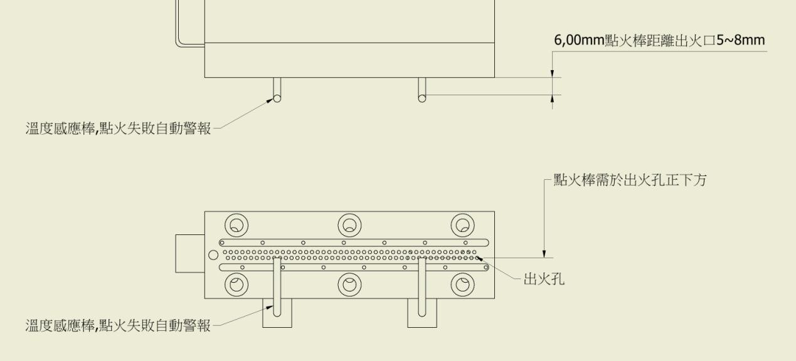
Operation sequence:
1. Adjust the inlet air pressure to 2KG.
2. Adjust the air pressure and flow rate-place your hand on the flame port and feel the slight amount of gas blowing out.
3. Press the ignition test button.
4. Turn on the gas and open the flow valve until the flame ignites.
5. Adjust the air pressure and gas flow to make the flame appear blue(note that it cannot be a red flame).
6. The flame is red, which means that the pressure and flow are too small and the gas is too large. When the flame is red, at this time, if you want a small flame, reduce the gas flow. If you want a large flame, increase the pressure and flow.

